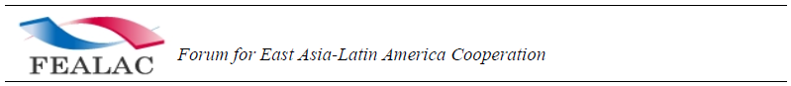

Investment opportunities

Sector
Title
Date |  | (ex. 2001-01-01)
Brief description of the Business opportunity
Brief description of the product/service
Brief description of the target market of the product/service
Brief description of the advantages of the company or cooperative to carry out the investment project
Brief description of the context of the investment opportunity
More information about the investment project
Country
City/Area
Total amount of the investment project | US$ million
% of th Investment contributed by the company or cooperative submitting the project | %
Minimum amount required from investor | US$ million
Payback period | years
Purpose of the Investment
Destination of the Investment
Investment Project's stage of development | Business plan  Mid-Stage development Advanced development
Type of public incentives available for the Investment Project
Type of investor required
Preferred Investment mode
Information about the Company/Cooperative submitting the Investment Project
Private Company National public organization Others
Contact point
Contact email should be that which corresponds to the focal point(email:) of each country

** Please fill out the form and submit it to the Cyber Secretariat fealac@mofa.go.kr or cybersecretariat@fealac.org.

